永磁直流行星齿轮电机（内齿圈材质:金属）
PM DC Planetary Gear Motor (Ring Gear Material: Metal)
Φ45 加强型减速器，允许转矩范围：1N.m~10N.m
45mm OD Reinforced Gearbox,
Permissible Load Range:1N.m~10N.m
45JX100K/45ZY68

- 外形和安装尺寸Dimensions

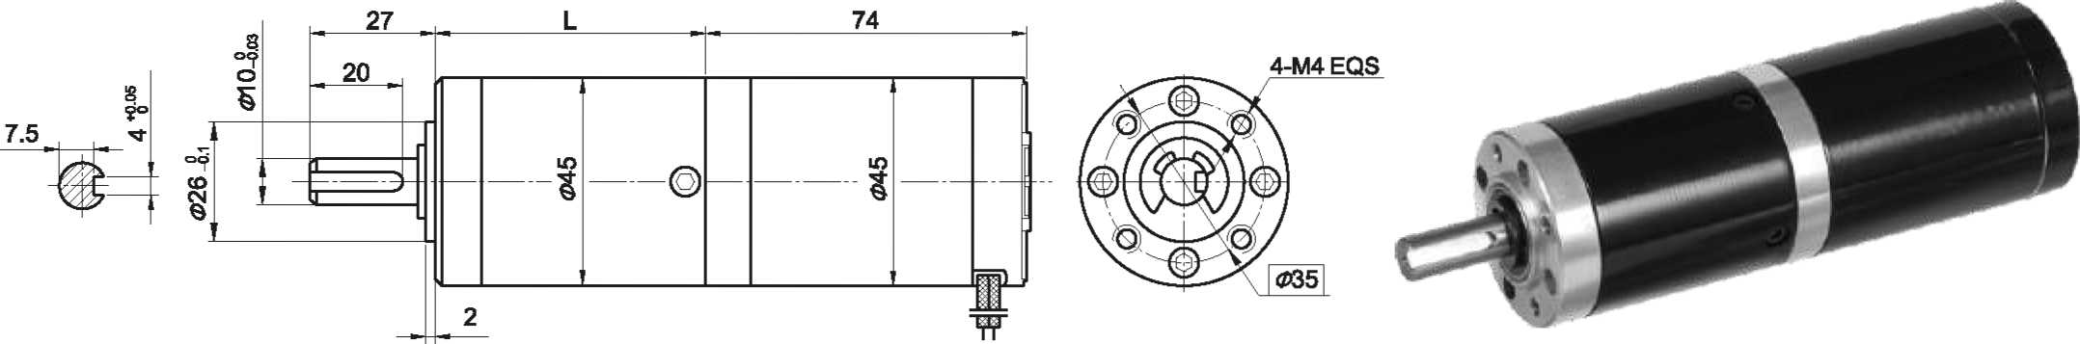
- 电动机主要技术参数Motor Technical Data
电机型号  TYPE | 额定电压  Rated  voltage  VDC | 空载转速  No-load  Speed  r/min | 空载电流  No-load  current  A | 额定转速  Rated  speed  r/min | 额定转矩  Rated  Torque  mN.m | 输出功率  Output  power  W | 额定电流  Rated  current  A | 堵转力矩  Stall t  orque  mN.m | 堵转电流  Stall  Current  A
45ZY68-2430 | 24 | 3000 | 0.20 | 2400 | 45 | 12 | 0.8 | 190 | 2.7
45ZY68-2440 | 24 | 4000 | 0.30 | 3200 | 55 | 18 | 1.2 | 195 | 3.0

- 齿轮减速电机主要技术参数Gear Motor Technical Data
配置45ZY68-2430直流电机(45ZY68-2430 DC Motor)
减速比 Reduction ratio | 3.71 | 5.18 | 14 | 19 | 27 | 51 | 71 | 100 | 139 | 189 | 264 | 369
减速级数 Number of gear trains | 1 | 1 | 2 | 2 | 2 | 3 | 3 | 3 | 3 | 4 | 4 | 4
减速器长度(L) Length(L) mm | 35.3 | 35.5 | 45.6 | 45.6 | 45.6 | 58.4 | 58.4 | 58.4 | 58.4 | 68.7 | 68.7 | 68.7
空载转速 No-load speed r/min | 809 | 579 | 214 | 158 | 111 | 59 | 42 | 30 | 22 | 16 | 11 | 8.1
额定转速 Rated speed r/min | 647 | 463 | 171 | 126 | 89 | 47 | 34 | 24 | 17 | 13 | 9.1 | 6.5
额定转矩 Rated torque N.m | 0.15 | 0.21 | 0.51 | 0.69 | 0.98 | 1.7 | 2.3 | 3.3 | 4.6 | 5.6 | 7.8 | 10
最大瞬间允许负载 N.m  Max. permissible load in a short time | 3 | 3 | 12 | 12 | 12 | 25 | 25 | 25 | 25 | 30 | 30 | 30
配置45ZY68-2440直流电机(45ZY68-2440 DC Motor)
减速比 Reduction ratio | 3.71 | 5.18 | 14 | 19 | 27 | 51 | 71 | 100 | 139 | 189 | 264 | 369
减速级数 Number of gear trains | 1 | 1 | 2 | 2 | 2 | 3 | 3 | 3 | 3 | 4 | 4 | 4
减速器长度(L) Length(L) mm | 35.3 | 35.5 | 45.6 | 45.6 | 45.6 | 58.4 | 58.4 | 58.4 | 58.4 | 68.7 | 68.7 | 68.7
空载转速 No-load speed r/min | 1078 | 772 | 286 | 211 | 148 | 78 | 56 | 40 | 29 | 21 | 15 | 11
额定转速 Rated speed r/min | 862 | 617 | 228 | 168 | 118 | 62 | 45 | 32 | 24 | 17 | 12 | 8.7
额定转矩 Rated torque N.m | 0.18 | 0.26 | 0.62 | 0.84 | 1.2 | 2.0 | 2.8 | 4.0 | 5.6 | 6.8 | 9.5 | 10
最大瞬间允许负载 N.m  Max. permissible load in a short time | 3 | 3 | 12 | 12 | 12 | 25 | 25 | 25 | 25 | 30 | 30 | 30

- 电动机特性图 Motor Characteristic Figure
技术参数如有变动，恕不另行通知
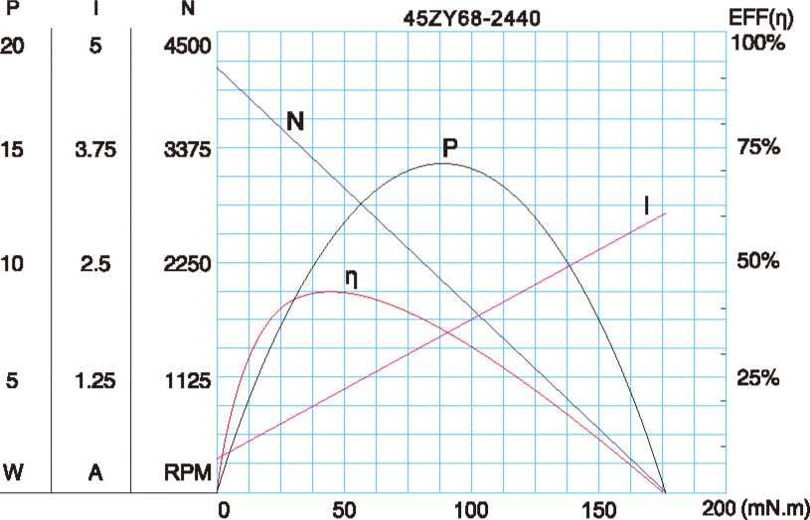
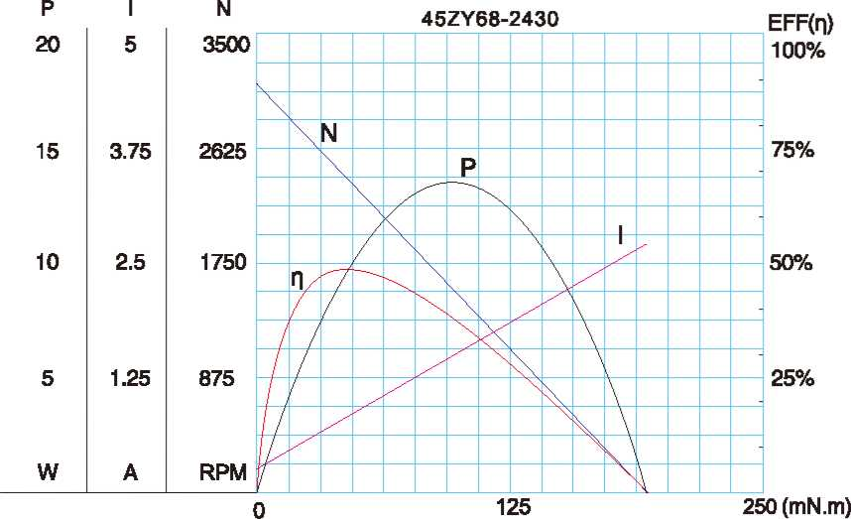

A-22

