永磁直流行星齿轮电机（内齿圈材质:金属和粉末金属）
PM DC Planetary Gear Motor (Ring Gear Material: Metal and Powder Metal)
42JXE100K/42ZY68P

Φ42 行星减速器，允许转矩范围：1N.m~10N.m
42mm OD Planetary Gearbox,
Permissible Load Range:1N.m~10N.m
可在两种材质的内齿圈中进行选择:粉末金属(型号42JXF100K),金属(型号42JXE100K)
Ring gear can be selected within the two materials : Powder metal(Type:42JXF100K), Metal(Type: 42JXE100K)
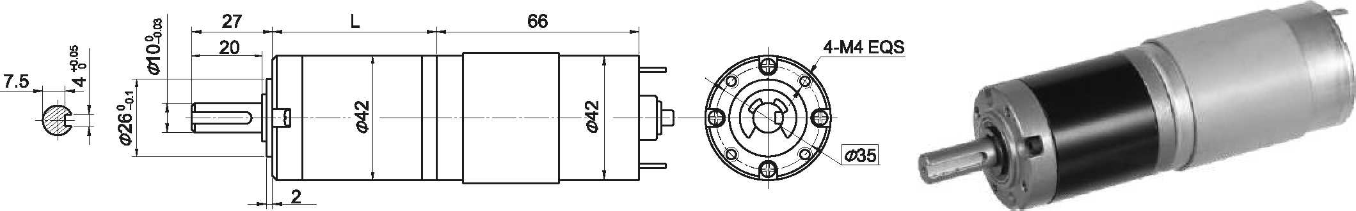
- 外形和安装尺寸Dimensions

- 电动机主要技术参数Motor Technical Data
电机型号  TYPE | 额定电压  Rated  voltage  VDC | 空载转速  No-load  Speed  r/min | 空载电流  No-load  current  A | 额定转速  Rated  speed  r/min | 额定转矩  Rated  Torque  mN.m | 输出功率  Output  power  W | 额定电流  Rated  current  A | 堵转力矩  Stall  Torque  mN.m | 堵转电流  Stall  Current  A
42ZY68P-2420 | 24 | 2000 | 0.15 | 1700 | 50 | 8.7 | 0.6 | 220 | 2.0
42ZY68P-2430 | 24 | 3000 | 0.17 | 2200 | 40 | 9.0 | 1.0 | 150 | 2.3

- 齿轮减速电机主要技术参数Gear Motor Technical Data
配置42ZY68P-2420直流电机(42ZY68P-2420 DC Motor)
减速比 Reduction ratio | 3.71 | 5.18 | 14 | 19 | 27 | 51 | 71 | 100 | 139 | 181 | 219 | 254 | 306 | 354
减速级数 Number of gear trains | 1 | 1 | 2 | 2 | 2 | 3 | 3 | 3 | 3 | 4 | 4 | 4 | 4 | 4
减速器长度(L) Length(L) mm | 31.5 | 31.5 | 42.1 | 42.1 | 42.1 | 52.5 | 52.5 | 52.5 | 52.5 | 62.9 | 62.9 | 62.9 | 62.9 | 62.9
空载转速 No-load speed r/min | 539 | 386 | 143 | 105 | 74 | 39 | 28 | 20 | 14 | 11 | 7.9 | 6.5 | 5.6 | 4.7
额定转速 Rated speed r/min | 458 | 328 | 121 | 89 | 63 | 33 | 24 | 17 | 12 | 9.4 | 6.7 | 5.6 | 4.8 | 4.0
额定转矩 Rated torque N.m | 0.17 | 0.23 | 0.57 | 0.77 | 1.1 | 1.9 | 2.6 | 3.7 | 5.1 | 6.1 | 8.3 | 1.0 | 10 | 10
最大瞬间允许负载 N.m  Max. permissible load in a short time | 3 | 3 | 12 | 12 | 12 | 25 | 25 | 25 | 25 | 30 | 30 | 30 | 30 | 30
配置42ZY68P-2430直流电机(42ZY68P-2430 DC Motor)
减速比 Reduction ratio | 3.7 | 5.2 | 14 | 19 | 27 | 51 | 71 | 100 | 139 | 181 | 219 | 254 | 306 | 354 | 427
减速级数 Number of gear trains | 1 | 1 | 2 | 2 | 2 | 3 | 3 | 3 | 3 | 4 | 4 | 4 | 4 | 4 | 4
减速器长度(L) Length(L) mm | 31.5 | 31.5 | 42.1 | 42.1 | 42.1 | 52.5 | 52.5 | 52.5 | 52.5 | 62.9 | 62.9 | 62.9 | 62.9 | 62.9 | 62.9
空载转速 No-load speed r/min | 809 | 579 | 214 | 158 | 111 | 59 | 42 | 30 | 22 | 16 | 14 | 12 | 10 | 8.5 | 7.0
额定转速 Rated speed r/min | 593 | 425 | 157 | 116 | 81 | 43 | 31 | 22 | 16 | 12 | 10 | 8.7 | 7.2 | 6.2 | 5.2
额定转矩 Rated torque N.m | 0.13 | 0.19 | 0.45 | 0.62 | 0.87 | 1.5 | 2.1 | 2.9 | 4.1 | 4.9 | 5.7 | 6.6 | 8.0 | 9.2 | 10
最大瞬间允许负载 N.m  Max. permissible load in a short time | 3 | 3 | 12 | 12 | 12 | 25 | 25 | 25 | 25 | 30 | 30 | 30 | 30 | 30 | 30

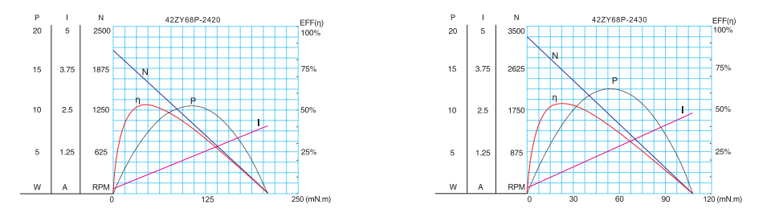
- 电动机特性图 Motor Characteristic Figure
技术参数如有变动，恕不另行通知

A-21

