永磁直流行星齿轮电机（内齿圈材质:金属）
PM DC Planetary Gear Motor (Ring Gear Material: Metal)
Φ42加强型减速器，允许转矩范围：2N.m~15 N.m
42mm OD Reinforced Gearbox,
Permissible Load Range: 2N.m~15 N.m
42JX150K/42ZY85

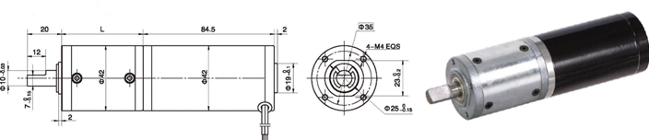
- 外形和安装尺寸Dimensions

- 电动机主要技术参数Motor Technical Data
电机型号  TYPE | 额定电压  Rated  voltage  VDC | 空载转速  No-load  Speed  r/min | 空载电流  No-load  current  A | 额定转速  Rated  Speed  r/min | 额定转矩  Rated  torque  mN.m | 输出功率  Output  Power  W | 额定电流  Rated  current  A | 堵转力矩  Stall  Torque  mN.m | 堵转电流  Stall  current  A
42ZY85-2430 | 24 | 3000 | 0.20 | 2400 | 70 | 15 | 1.2 | 280 | 3.7
42ZY85-2436 | 24 | 3600 | 0.30 | 2850 | 80 | 23 | 1.5 | 290 | 4.7

- 齿轮减速电机主要技术参数Gear Motor Technical Data
配置42ZY85-2430直流电机(42ZY85-2430 DC Motor)
减速比 Reduction ratio | 3.5 | 14 | 17 | 21 | 49 | 61 | 84 | 104 | 126 | 172 | 212 | 294
减速级数 Number of gear trains | 1 | 2 | 2 | 2 | 3 | 3 | 3 | 3 | 3 | 4 | 4 | 4
减速器长度(L) Length(L) mm | 32.5 | 39.2 | 39.2 | 39.2 | 46 | 46 | 46 | 46 | 46 | 52.5 | 52.5 | 52.5
空载转速 No-load speed r/min | 857 | 214 | 176 | 143 | 61 | 49 | 36 | 28 | 24 | 17 | 14 | 10
额定转速 Rated speed r/min | 686 | 171 | 141 | 114 | 49 | 39 | 29 | 23 | 19 | 14 | 11 | 8
额定转矩 Rated torque N.m | 0.22 | 0.79 | 0.96 | 1.2 | 2.5 | 3.1 | 4.2 | 5.3 | 6.4 | 7.9 | 9.8 | 13
最大瞬间允许负载 N.m  Max. permissible load in a short time | 3 | 12 | 12 | 12 | 25 | 25 | 25 | 25 | 25 | 30 | 30 | 30
配置42ZY85-2436直流电机(42ZY85-2436 DC Motor)
减速比 Reduction ratio | 3.5 | 14 | 17 | 21 | 49 | 61 | 84 | 104 | 126 | 172 | 212 | 294
减速级数 Number of gear trains | 1 | 2 | 2 | 2 | 3 | 3 | 3 | 3 | 3 | 4 | 4 | 4
减速器长度(L) Length(L) mm | 32.5 | 39.2 | 39.2 | 39.2 | 46 | 46 | 46 | 46 | 46 | 52.5 | 52.5 | 52.5
空载转速 No-load speed r/min | 1028 | 257 | 211 | 171 | 73 | 59 | 43 | 34 | 28 | 21 | 17 | 12
额定转速 Rated speed r/min | 814 | 203 | 167 | 136 | 58 | 48 | 34 | 27 | 22 | 16 | 13 | 10
额定转矩 Rated torque N.m | 0.25 | 0.90 | 1.1 | 1.3 | 2.8 | 3.5 | 4.9 | 6.0 | 7.3 | 9.0 | 11 | 15
最大瞬间允许负载 N.m  Max. permissible load in a short time | 3 | 12 | 12 | 12 | 25 | 25 | 25 | 25 | 25 | 30 | 30 | 30

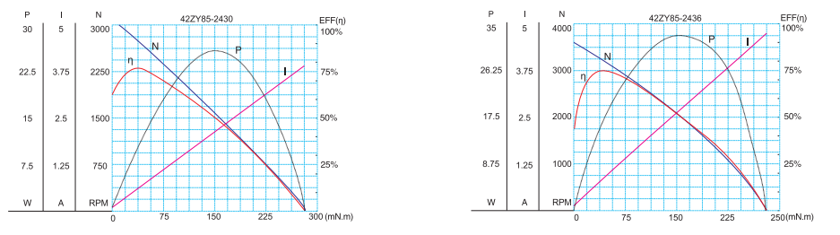
- 电动机特性图 Motor Characteristic Figure
技术参数如有变动，恕不另行通知

A-20

