永磁直流行星齿轮电机（内齿圈材质:金属）
PM DC Planetary Gear Motor (Ring Gear Material: Metal)
Φ42 加强型减速器，允许转矩范围：2N.m~15N.m
42mm OD Reinforced Gearbox,
Permissible Load Range:2N.m~15N.m
42JX150K/42ZY66

- 外形和安装尺寸Dimensions

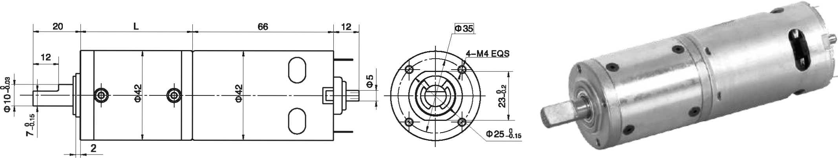

- 电动机主要技术参数Motor Technical Data
电机型号  TYPE | 额定电压  Rated  voltage  VDC | 空载转速  No-load  speed  r/min | 空载电流  No-load  current  A | 额定转速  Rated  speed  r/min | 额定转矩  Rated  torque  mN.m | 输出功率 Output  power  W | 额定电流  Rated  current  A | 堵转力矩  Stall  Torque  mN.m | 堵转电流  Stall  current  A
42ZY66-1257 | 12 | 5700 | 0.8 | 4800 | 45 | 25 | 3.0 | 280 | 15.2
42ZY66-1277 | 12 | 7700 | 1.3 | 6500 | 65 | 35 | 5.0 | 240 | 20.5

- 齿轮减速电机主要技术参数Gear Motor Technical Data
配置42ZY66-1257直流电机(42ZY66-1257 DC Motor)
减速比 Reduction ratio | 3.5 | 14 | 17 | 21 | 49 | 61 | 84 | 104 | 126 | 172 | 212 | 294 | 504
减速级数 Number of gear trains | 1 | 2 | 2 | 2 | 3 | 3 | 3 | 3 | 3 | 4 | 4 | 4 | 4
减速器长度(L) Length(L) mm | 32.5 | 39.2 | 39.2 | 39.2 | 46 | 46 | 46 | 46 | 46 | 52.5 | 52.5 | 52.5 | 52.5
空载转速 No-load speed r/min | 1628 | 407 | 335 | 271 | 116 | 93 | 68 | 55 | 45 | 33 | 27 | 19 | 11
额定转速 Rated speed r/min | 1371 | 343 | 285 | 229 | 98 | 79 | 57 | 47 | 38 | 28 | 23 | 16 | 9.5
额定转矩 Rated torque N.m | 0.14 | 0.51 | 0.61 | 0.76 | 1.6 | 2.0 | 2.8 | 3.4 | 4.1 | 5.1 | 6.3 | 8.7 | 15
最大瞬间允许负载 N.m  Max. permissible load in a short time | 3 | 12 | 12 | 12 | 25 | 25 | 25 | 25 | 25 | 30 | 30 | 30 | 30
配置42ZY66-1277直流电机(42ZY66-1277 DC Motor)
减速比 Reduction ratio | 3.5 | 14 | 17 | 21 | 49 | 61 | 84 | 104 | 126 | 172 | 212 | 294
减速级数 Number of gear trains | 1 | 2 | 2 | 2 | 3 | 3 | 3 | 3 | 3 | 4 | 4 | 4
减速器长度(L) Length(L) mm | 32.5 | 39.2 | 39.2 | 39.2 | 46 | 39.2 | 46 | 46 | 46 | 52.5 | 52.5 | 52.5
空载转速 No-load speed r/min | 2200 | 550 | 453 | 367 | 157 | 126 | 92 | 74 | 61 | 45 | 36 | 26
额定转速 Rated speed r/min | 1857 | 464 | 382 | 310 | 133 | 106 | 77 | 62 | 51 | 38 | 30 | 22
额定转矩 Rated torque N.m | 0.21 | 0.74 | 0.89 | 1.1 | 2.3 | 2.8 | 4.0 | 4.9 | 6.0 | 8.2 | 9.0 | 14
最大瞬间允许负载 N.m  Max. permissible load in a short time | 3 | 12 | 12 | 12 | 25 | 25 | 25 | 25 | 25 | 30 | 30 | 30
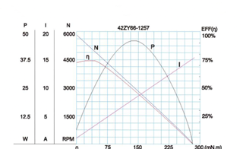
- 电动机特性图 Motor Characteristic Figure
技术参数如有变动，恕不另行通知
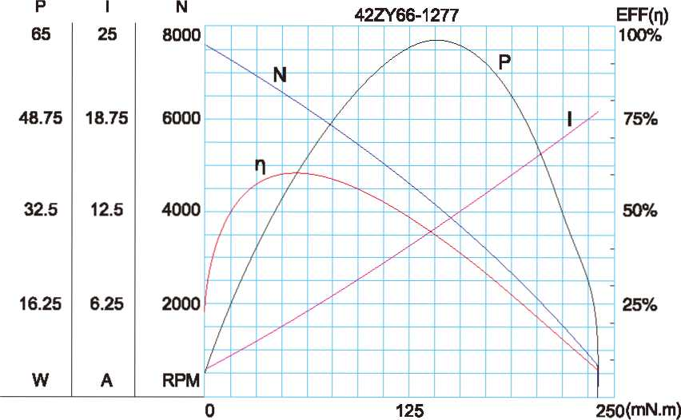

A-19

