永磁直流行星齿轮电机（内齿圈材质:金属和粉末金属）
PM DC Planetary Gear Motor (Ring Gear Material: Metal and Powder Metal)
Φ36 行星减速器，允许转矩范围：0.3N.m~3.0N.m
36mm OD Planetary Gearbox,
Permissible Load Range:0.3N.m~3.0N.m
36JXE30K/36ZY50

可在两种材料的内齿圈中进行选择：粉末金属(型号36JXF30K),金属(型号36JXE30K)
Ring gear can be selected within the two materials: Powder metal (Type:36JXF30K), Metal (Type:36JXE30K)
- 外形和安装尺寸Dimensions

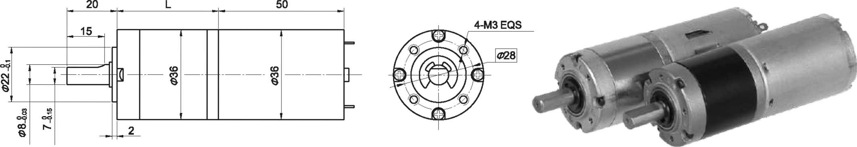

- 电动机主要技术参数Motor Technical Data
电机型号  TYPE | 额定电压 Rated  voltage  VDC | 空载转速  No-load  speed  r/min | 空载电流  No-load  current  mA | 额定转速  Rated  Speed  r/min | 额定转矩  Rated  torque  mN.m | 输出功率 Output  Power  W | 额定电流  Rated  current  A | 堵转力矩  Stall  Torque  mN.m | 堵转电流  Stall  current  A
36ZY50-2436 | 24 | 3600 | 100 | 3000 | 11 | 3.4 | 0.40 | 58 | 1.7
36ZY50-2442 | 24 | 4200 | 120 | 3450 | 12 | 4.2 | 0.43 | 56 | 1.6

- 齿轮减速电机主要技术参数Gear Motor Technical Data
配置36ZY50-2436直流电机(36ZY50-2436 DC Motor)
减速比 Reduction ratio | 3.7 | 5.2 | 14 | 19 | 27 | 51 | 71 | 100 | 139 | 189 | 264 | 369 | 516
减速级数 Number of gear trains | 1 | 1 | 2 | 2 | 2 | 3 | 3 | 3 | 3 | 4 | 4 | 4 | 4
减速器长度(L) Length(L) mm | 26.5 | 26.5 | 33.6 | 33.6 | 33.6 | 40.5 | 40.5 | 40.5 | 40.5 | 47.4 | 47.4 | 47.4 | 47.4
空载转速 No-load speed r/min | 970 | 695 | 257 | 189 | 133 | 71 | 51 | 36 | 26 | 19 | 14 | 9.8 | 7.0
额定转速 Rated speed r/min | 809 | 579 | 214 | 158 | 111 | 59 | 42 | 30 | 22 | 16 | 11 | 8.1 | 5.8
额定转矩 Rated torque N.m | 0.037 | 0.051 | 0.12 | 0.17 | 0.24 | 0.41 | 0.57 | 0.80 | 1.1 | 1.4 | 1.9 | 2.6 | 3
最大瞬间允许负载 N.m  Max. permissible load in a short time | 1.0 | 1.0 | 3.5 | 3.5 | 3.5 | 7.5 | 7.5 | 7.5 | 7.5 | 9 | 9 | 9 | 9
配置36ZY50-2442直流电机(36ZY50-2442 DC Motor)
减速比 Reduction ratio | 3.7 | 5.2 | 14 | 19 | 27 | 51 | 71 | 100 | 139 | 189 | 264 | 369 | 516
减速级数 Number of gear trains | 1 | 1 | 2 | 2 | 2 | 3 | 3 | 3 | 3 | 4 | 4 | 4 | 4
减速器长度(L) Length(L) mm | 26.5 | 26.5 | 33.6 | 33.6 | 33.6 | 40.5 | 40.5 | 40.5 | 40.5 | 47.4 | 47.4 | 47.4 | 47.4
空载转速 No-load speed r/min | 1132 | 811 | 300 | 221 | 156 | 82 | 59 | 42 | 30 | 22 | 16 | 11 | 8.1
额定转速 Rated speed r/min | 930 | 666 | 246 | 182 | 128 | 68 | 49 | 35 | 25 | 18 | 13 | 9.3 | 6.7
额定转矩 Rated torque N.m | 0.040 | 0.056 | 0.14 | 0.18 | 0.26 | 0.45 | 0.62 | 0.88 | 1.2 | 1.5 | 2.1 | 2.9 | 3
最大瞬间允许负载 N.m  Max. permissible load in a short time | 1.0 | 1.0 | 3.5 | 3.5 | 3.5 | 7.5 | 7.5 | 7.5 | 7.5 | 9 | 9 | 9 | 9

- 电动机特性图 Motor Characteristic Figure
技术参数如有变动，恕不另行通知
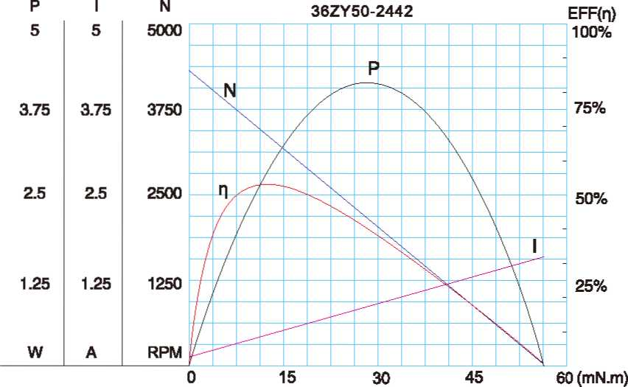
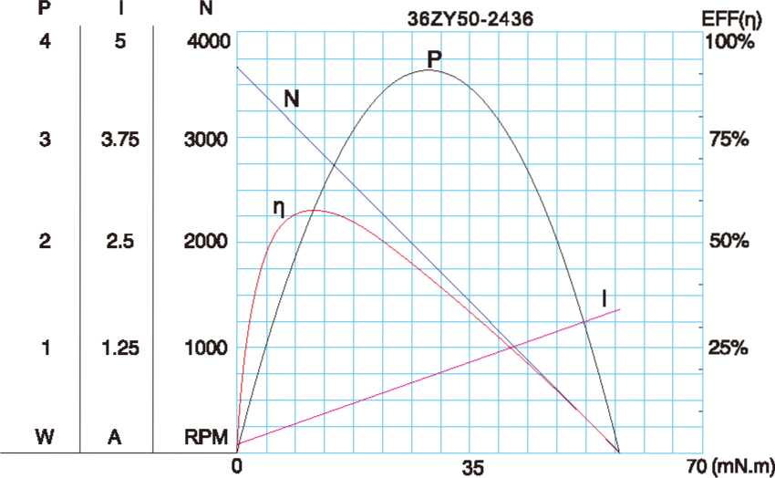

A-17

