永磁直流行星齿轮电机（内齿圈材质:金属和粉末金属）
PM DC Planetary Gear Motor (Ring Gear Material: Metal and Powder Metal)
Φ36 行星减速器，允许转矩范围：0.3N.m~3.0N.m
36mm OD Planetary Gearbox,
Permissible Load Range:0.3N.m~3.0N.m
36JXE30K/35ZY40

可在两种材料的内齿圈中进行选择：粉末金属(型号36JXF30K),金属(型号36JXE30K)
Ring gear can be selected within the two materials: Powder metal (Type:36JXF30K), Metal (Type:36JXE30K)
- 外形和安装尺寸Dimensions

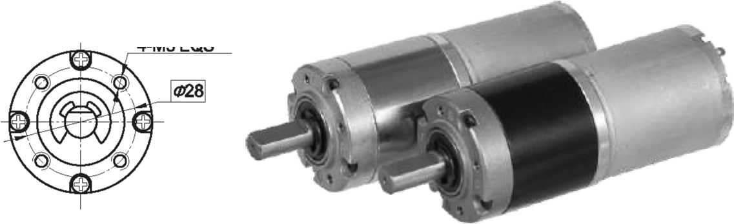
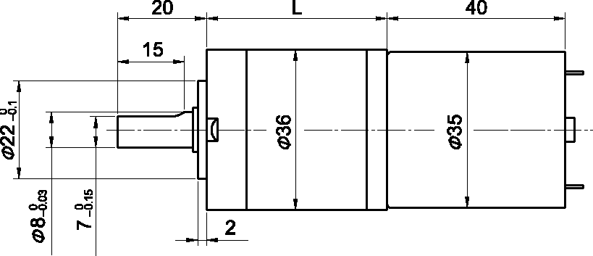
4-M3 EQS

- 电动机主要技术参数Motor Technical Data
电机型号  TYPE | 额定电压  Rated  Voltage  VDC | 空载转速  No-load  speed  r/min | 空载电流  No-load  current  mA | 额定转速  Rated  speed  r/min | 额定转矩  Rated  torque  mN.m | 输出功率 Output  power  W | 额定电流  Rated  current  mA | 堵转力矩  Stall  torque  mN.m | 堵转电流  Stall  current  A
35ZY40-1230 | 12 | 3000 | 90 | 2300 | 9 | 2.1 | 400 | 22 | 0.8
35ZY40-1250 | 12 | 5000 | 110 | 4300 | 8 | 3.5 | 600 | 34 | 2.2

- 齿轮减速电机主要技术参数Gear Motor Technical Data
配置35ZY40-1230直流电机(35ZY30-1230 DC Motor)
减速比 Reduction ratio | 3.7 | 5.2 | 14 | 19 | 27 | 51 | 71 | 100 | 139 | 189 | 264 | 369 | 516 | 720
减速级数 Number of gear trains | 1 | 1 | 2 | 2 | 2 | 3 | 3 | 3 | 3 | 4 | 4 | 4 | 4 | 4
减速器长度(L) Length(L) mm | 26.5 | 26.5 | 33.6 | 33.6 | 33.6 | 40.5 | 40.5 | 40.5 | 40.5 | 47.4 | 47.4 | 47.4 | 47.4 | 47.4
空载转速 No-load speed r/min | 809 | 579 | 214 | 158 | 111 | 59 | 42 | 30 | 22 | 16 | 11 | 8.1 | 5.8 | 4.2
额定转速 Rated speed r/min | 620 | 444 | 164 | 121 | 85 | 45 | 32 | 23 | 17 | 12 | 8.7 | 6.2 | 4.5 | 3.2
额定转矩 Rated torque N.m | 0.030 | 0.042 | 0.10 | 0.14 | 0.20 | 0.34 | 0.47 | 0.66 | 0.91 | 1.1 | 1.5 | 2.2 | 3 | 3
最大瞬间允许负载 N.m  Max. permissible load in a short time | 1.0 | 1.0 | 3.5 | 3.5 | 3.5 | 7.5 | 7.5 | 7.5 | 7.5 | 9 | 9 | 9 | 9 | 9
配置35ZY40-1250直流电机(35ZY40-1250 DC Motor)
减速比 Reduction ratio | 3.7 | 5.2 | 14 | 19 | 27 | 51 | 71 | 100 | 139 | 189 | 264 | 369 | 516 | 720
减速级数 Number of gear trains | 1 | 1 | 2 | 2 | 2 | 3 | 3 | 3 | 3 | 4 | 4 | 4 | 4 | 4
减速器长度(L) Length(L) mm | 26.5 | 26.5 | 33.6 | 33.6 | 33.6 | 40.5 | 40.5 | 40.5 | 40.5 | 47.4 | 47.4 | 47.4 | 47.4 | 47.4
空载转速 No-load speed r/min | 1348 | 965 | 357 | 263 | 185 | 98 | 70 | 50 | 36 | 26 | 19 | 14 | 10 | 6.9
额定转速 Rated speed r/min | 1159 | 830 | 307 | 226 | 159 | 84 | 61 | 43 | 31 | 23 | 16 | 12 | 8.3 | 6.0
额定转矩 Rated torque N.m | 0.027 | 0.037 | 0.09 | 0.12 | 0.17 | 0.30 | 0.41 | 0.58 | 0.81 | 0.98 | 1.4 | 1.9 | 2.7 | 3
最大瞬间允许负载 N.m  Max. permissible load in a short time | 1.0 | 1.0 | 3.5 | 3.5 | 3.5 | 7.5 | 7.5 | 7.5 | 7.5 | 9 | 9 | 9 | 9 | 9

- 电动机特性图 Motor Characteristic Figure
技术参数如有变动，恕不另行通知
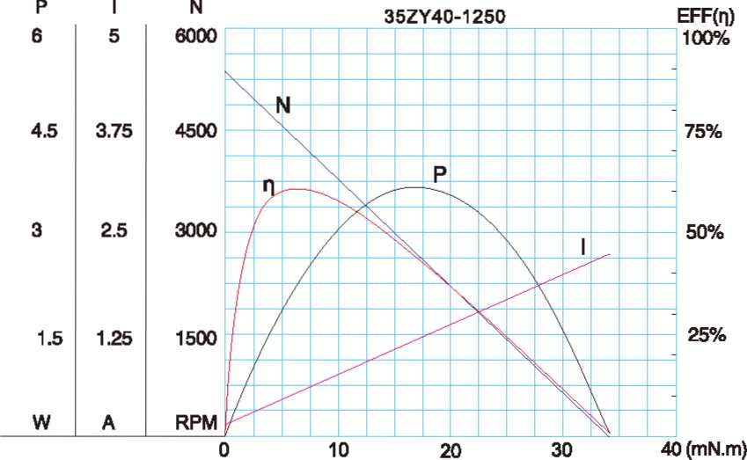
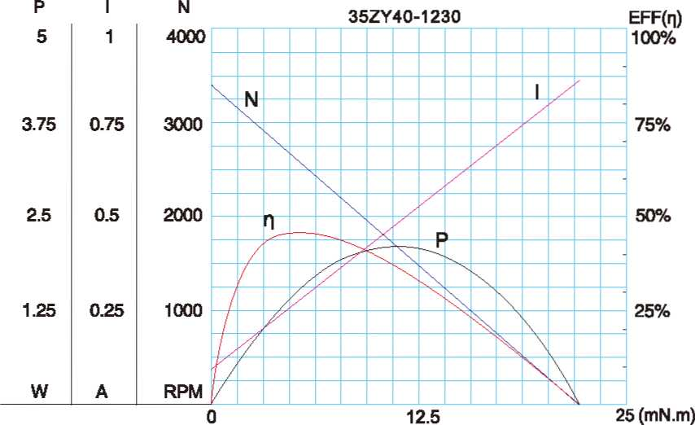

A-16

