永磁直流行星齿轮电机（内齿圈材质:金属）
PM DC Planetary Gear Motor (Ring Gear Material: Metal )
Φ36 行星减速器，允许转矩范围：0.3N.m~3.0N.m
36mm OD Planetary Gearbox,
Permissible Load Range:0.3N.m~3.0N.m
36JX30K/38ZY63

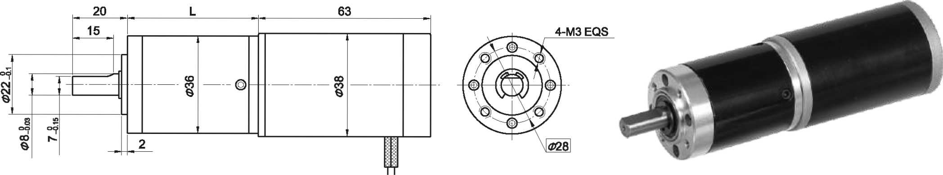
- 外形和安装尺寸Dimensions

- 电动机主要技术参数Motor Technical Data
电机型号  TYPE | 额定电压 Rated  Voltage  VDC | 空载转速  No-load  Speed  r/min | 空载电流  No-load  current  mA | 额定转速  Rated  Speed  r/min | 额定转矩  Rated  torque  mN.m | 输出功率 Output  power  W | 额定电流  Rated  Current  mA | 堵转力矩  Stall  Torque  mN.m | 堵转电流  Stall  current  A
38ZY63-2430 | 24 | 3000 | 160 | 2500 | 15 | 3.8 | 0.35 | 65 | 1.0
38ZY63-2440 | 24 | 4000 | 220 | 3200 | 20 | 6.5 | 0.60 | 90 | 2.0

- 齿轮减速电机主要技术参数Gear Motor Technical Data
配置38ZY63-2430直流电机(38ZY63-2430 DC Motor)
减速比 Reduction ratio | 3.7 | 5.1 | 14 | 19 | 27 | 51 | 71 | 100 | 139 | 189 | 264 | 369
减速级数 Number of gear trains | 1 | 1 | 2 | 2 | 2 | 3 | 3 | 3 | 3 | 4 | 4 | 4
减速器长度(L) Length(L) mm | 31.0 | 31.0 | 38.5 | 38.5 | 38.5 | 48.4 | 48.4 | 48.4 | 48.4 | 55.8 | 55.8 | 55.8
空载转速 No-load speed r/min | 809 | 579 | 214 | 158 | 111 | 59 | 42 | 30 | 22 | 16 | 11 | 8
额定转速 Rated speed r/min | 670 | 480 | 175 | 130 | 92 | 49 | 35 | 25 | 18 | 13 | 9.5 | 7
额定转矩 Rated torque N.m | 0.050 | 0.070 | 0.17 | 0.23 | 0.33 | 0.56 | 0.78 | 1.1 | 1.5 | 1.8 | 2.6 | 3
最大瞬间允许负载 N.m  Max. permissible load in a short time | 1.0 | 1.0 | 3.5 | 3.5 | 3.5 | 7.5 | 7.5 | 7.5 | 7.5 | 9 | 9 | 9
配置38ZY63-2440直流电机(38ZY63-2440 DC Motor)
减速比 Reduction ratio | 3.7 | 5.1 | 14 | 19 | 27 | 51 | 71 | 100 | 139 | 189 | 264 | 369
减速级数 Number of gear trains | 1 | 1 | 2 | 2 | 2 | 3 | 3 | 3 | 3 | 4 | 4 | 4
减速器长度(L) Length(L) mm | 31.0 | 31.0 | 38.5 | 38.5 | 38.5 | 48.4 | 48.4 | 48.4 | 48.4 | 55.8 | 55.8 | 55.8
空载转速 No-load speed r/min | 1078 | 772 | 286 | 211 | 148 | 78 | 56 | 40 | 29 | 21 | 15 | 11
额定转速 Rated speed r/min | 860 | 617 | 228 | 168 | 118 | 62 | 45 | 32 | 23 | 17 | 13 | 10
额定转矩 Rated torque N.m | 0.067 | 0.093 | 0.23 | 0.31 | 0.44 | 0.74 | 1.0 | 1.5 | 2.0 | 2.5 | 3 | 3
最大瞬间允许负载 N.m  Max. permissible load in a short time | 1.0 | 1.0 | 3.5 | 3.5 | 3.5 | 7.5 | 7.5 | 7.5 | 7.5 | 9 | 9 | 9
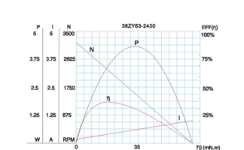
- 电动机特性图 Motor Characteristic Figure
技术参数如有变动，恕不另行通知
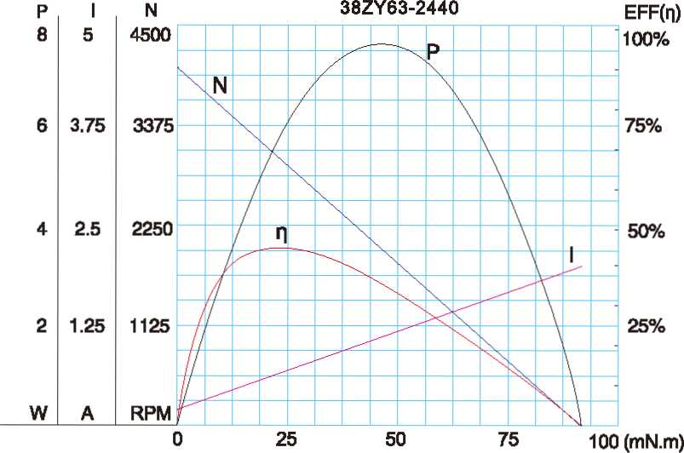

A-14

