永磁直流行星齿轮电机（内齿圈材质:金属）
PM DC Planetary Gear Motor (Ring Gear Material: Metal)
Φ36 行星减速器，允许转矩范围：0.3N.m~3.0N.m
36mm OD Planetary Gearbox,
Permissible Load Range:0.3N.m~3.0N.m
36JX30K/36ZY85P

- 外形和安装尺寸Dimensions

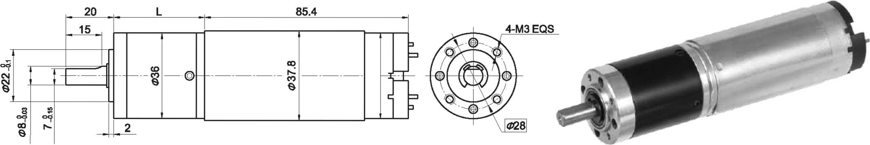

- 电动机主要技术参数Motor Technical Data
电机型号  TYPE | 额定电压 Rated  voltage  VDC | 空载转速  No-load  Speed  r/min | 空载电流  No-load  current  mA | 额定转速  Rated  Speed  r/min | 额定转矩  Rated  torque  mN.m | 输出功率 Output  Power  W | 额定电流  Rated  current  A | 堵转力矩  Stall  Torque  mN.m | 堵转电流  Stall  current  A
36ZY85P-1230 | 12 | 3000 | 250 | 2400 | 40 | 10 | 1.60 | 188 | 6.7
36ZY85P-2430 | 24 | 3000 | 150 | 2500 | 40 | 10 | 0.85 | 285 | 4.2

- 齿轮减速电机主要技术参数Gear Motor Technical Data
配置36ZY85P-1230直流电机(36ZY85P-1230 DC Motor)
减速比 Reduction ratio | 3.7 | 5.2 | 14 | 19 | 27 | 51 | 71 | 100 | 139
减速级数 Number of gear trains | 1 | 1 | 2 | 2 | 2 | 3 | 3 | 3 | 3
减速器长度(L) Length(L) mm | 31.0 | 31.0 | 38.5 | 38.5 | 38.5 | 48.4 | 48.4 | 48.4 | 48.4
空载转速 No-load speed r/min | 809 | 579 | 214 | 157 | 111 | 59 | 42 | 30 | 21
额定转速 Rated speed r/min | 649 | 462 | 171 | 126 | 89 | 47 | 34 | 24 | 18
额定转矩 Rated torque N.m | 0.13 | 0.19 | 0.45 | 0.62 | 0.87 | 1.5 | 2.1 | 2.9 | 3
最大瞬间允许负载 N.m  Max. permissible load in a short time | 1.0 | 1.0 | 3.5 | 3.5 | 3.5 | 7.5 | 9 | 9 | 9
配置36ZY85P-2430直流电机(36ZY85P-2430 DC Motor)
减速比 Reduction ratio | 3.7 | 5.2 | 14 | 19 | 27 | 51 | 71 | 100 | 139
减速级数 Number of gear trains | 1 | 1 | 2 | 2 | 2 | 3 | 3 | 3 | 3
减速器长度(L) Length(L) mm | 31.0 | 31.0 | 38.5 | 38.5 | 38.5 | 48.4 | 48.4 | 48.4 | 48.4
空载转速 No-load speed r/min | 809 | 579 | 214 | 157 | 111 | 59 | 42 | 30 | 21
额定转速 Rated speed r/min | 674 | 483 | 179 | 132 | 93 | 49 | 35 | 25 | 19
额定转矩 Rated torque N.m | 0.13 | 0.19 | 0.45 | 0.62 | 0.87 | 1.5 | 2.1 | 2.9 | 3
最大瞬间允许负载 N.m  Max. permissible load in a short time | 1.0 | 1.0 | 3.5 | 3.5 | 3.5 | 7.5 | 9 | 9 | 9

- 电动机特性图 Motor Characteristic Figure
技术参数如有变动，恕不另行通知
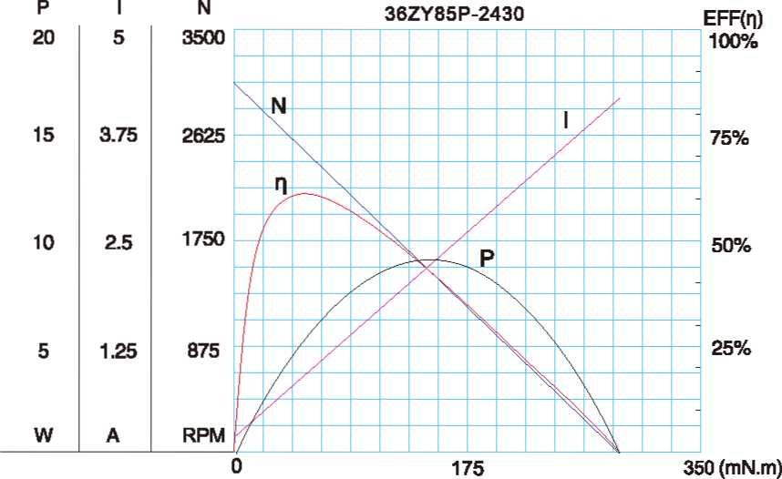
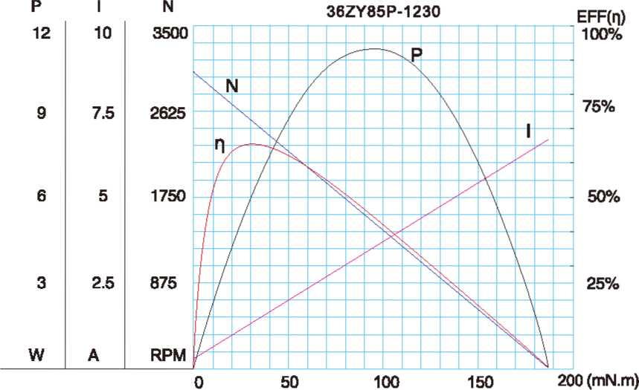

A-13

