永磁直流行星齿轮电机（内齿圈材质:金属）
PM DC Planetary Gear Motor (Ring Gear Material: Metal)
32jxe20k/28zy47p
Φ32行星减速器，允许转矩范围：0.2N.m~2.0N.m
32mm OD Planetary Gearbox,
Permissible Load Range:0.2N.m~2.0N.m

常规产品出轴直径Φ6,也可以配置直径Φ8的出轴。Standard output shaft OD 6mm, OD 8mm optional.

- 外形和安装尺寸Dimensions
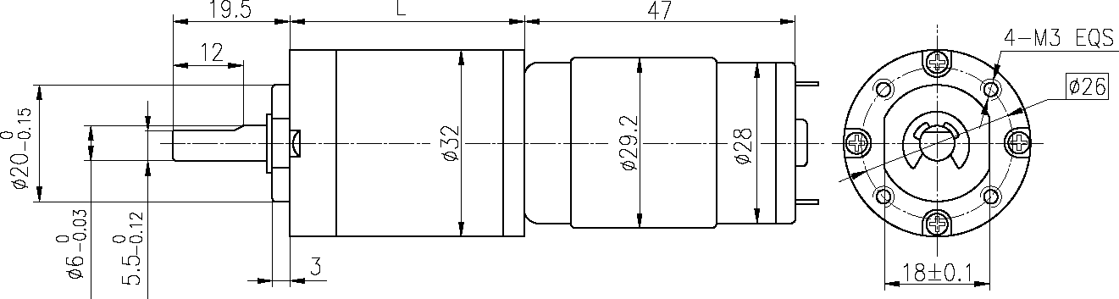
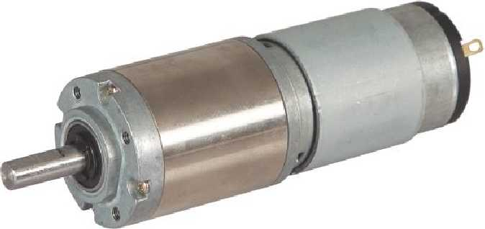

- 电动机主要技术参数Motor Technical Data
电机型号  Type | 额定电压  Rated  Voltage  VDC | 空载转速  No-load  Speed  r/min | 空载电流  No-load current  mA | 额定转速  Rated  Speed  r/min | 额定转矩  Rated  torque  mN.m | 输出功率  Output  power  W | 额定电流  Rated  current  mA | 堵转力矩  Stall  torque  mN.m | 堵转电流  Stall  current  A
28ZY47P-1273 | 12 | 7300 | 150 | 5950 | 10.8 | 6.7 | 900 | 32 | 2.7
28ZY47P-2473 | 24 | 7300 | 85 | 6160 | 12.7 | 8.2 | 500 | 38 | 1.5

- 齿轮减速电机主要技术参数Gear Motor Technical Data
配置28ZY47P-1273直流电机(28ZY47P-1273 DC Motor)
减速比 Reduction ratio | 3.7 | 5.2 | 14 | 19 | 27 | 35 | 51 | 71 | 100 | 139 | 189 | 254 | 354 | 495 | 596
减速级数 Number of gear trains | 1 | 1 | 2 | 2 | 2 | 2 | 3 | 3 | 3 | 3 | 4 | 4 | 4 | 4 | 4
减速器长度(L) Length(L) mm | 25.7 | 25.7 | 32.8 | 32.8 | 32.8 | 32.8 | 39.7 | 39.7 | 39.7 | 39.7 | 46.6 | 46.6 | 46.6 | 46.6 | 46.6
空载转速 No-load speed r/min | 1968 | 1409 | 521 | 384 | 270 | 209 | 143 | 103 | 73 | 53 | 39 | 29 | 21 | 15 | 12
额定转速 Rated speed r/min | 1604 | 1149 | 425 | 313 | 220 | 170 | 117 | 84 | 60 | 43 | 31 | 23 | 17 | 12 | 10
额定转矩 Rated torque N.m | 0.036 | 0.050 | 0.12 | 0.17 | 0.24 | 0.31 | 0.40 | 0.56 | 0.79 | 1.1 | 1.3 | 1.8 | 2.0 | 2.0 | 2.0
最大瞬间允许负载 N.m  Max. permissible load in a short time | 0.6 | 0.6 | 2.4 | 2.4 | 2.4 | 2.4 | 4.8 | 4.8 | 4.8 | 4.8 | 4.8 | 4.8 | 4.8 | 4.8 | 4.8

配置28ZY47P-2473直流电机(28ZY47P-2473 DC Motor)
减速比 Reduction ratio | 3.7 | 5.2 | 14 | 19 | 27 | 35 | 51 | 71 | 100 | 139 | 189 | 254 | 354 | 495 | 596
减速级数 Number of gear trains | 1 | 1 | 2 | 2 | 2 | 2 | 3 | 3 | 3 | 3 | 4 | 4 | 4 | 4 | 4
减速器长度(L) Length(L) mm | 25.7 | 25.7 | 32.8 | 32.8 | 32.8 | 32.8 | 39.7 | 39.7 | 39.7 | 39.7 | 46.6 | 46.6 | 46.6 | 46.6 | 46.6
空载转速 No-load speed r/min | 1968 | 1409 | 521 | 384 | 270 | 209 | 143 | 103 | 73 | 53 | 39 | 29 | 21 | 15 | 12
额定转速 Rated speed r/min | 1660 | 1189 | 440 | 324 | 228 | 176 | 121 | 87 | 62 | 44 | 33 | 24 | 17 | 12 | 10
额定转矩 Rated torque N.m | 0.042 | 0.059 | 0.14 | 0.20 | 0.28 | 0.36 | 0.47 | 0.66 | 0.93 | 1.3 | 1.6 | 2.0 | 2.0 | 2.0 | 2.0
最大瞬间允许负载 N.m  Max. permissible load in a short time | 0.6 | 0.6 | 2.4 | 2.4 | 2.4 | 2.4 | 4.8 | 4.8 | 4.8 | 4.8 | 4.8 | 4.8 | 4.8 | 4.8 | 4.8

- 电动机特性图 Motor Characteristic Figure
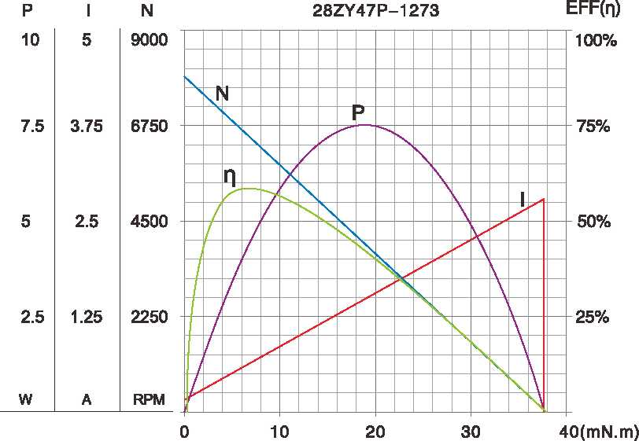
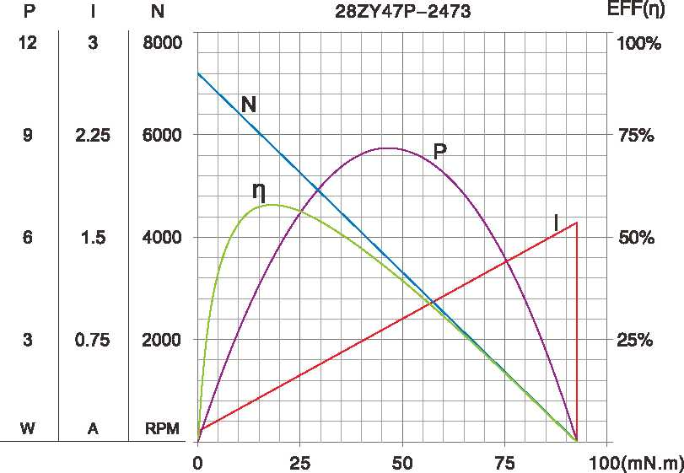

A-10
技术参数如有变动，恕不另行通知

